Psalm 125 Common Worship Chant: C.H. Lloyd

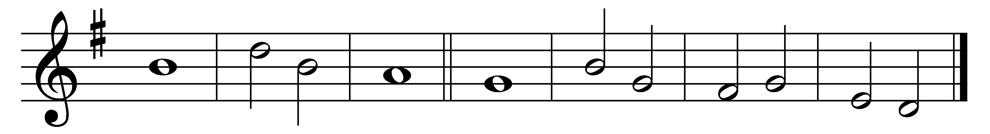

Those who trust in the Lord are like | Mount | Zion,
which cannot be moved, but | stands | fast for | ever.

2 As the hills | stand a-· bout Je-| rusalem,
so the Lord stands round about his people, from this time | forth for | ever-| more.

3 The sceptre of wickedness shall not hold sway over the land al-| lotted· to the | righteous,
lest the | righteous· turn their | hands to | evil.

4 Do good, O Lord, to | those· who are | good,
and to | those· who are | true of | heart.

5 Those who turn aside to crooked ways the Lord shall take away with the | evil-| doers;
but | let there· be | peace up-· on | Isra-· el.

Words taken from Common Worship © The Archbishops’ Council 2000.

